Practical No.2

1. Line Graph
x <- c(1, 2, 3, 4, 5)
y <- c(10, 20, 15, 30, 25)

plot(x, y,
type = "l",
main = "Line Graph",
xlab = "X Values",
ylab = "Y Values")
type = "l" means line.
Output:
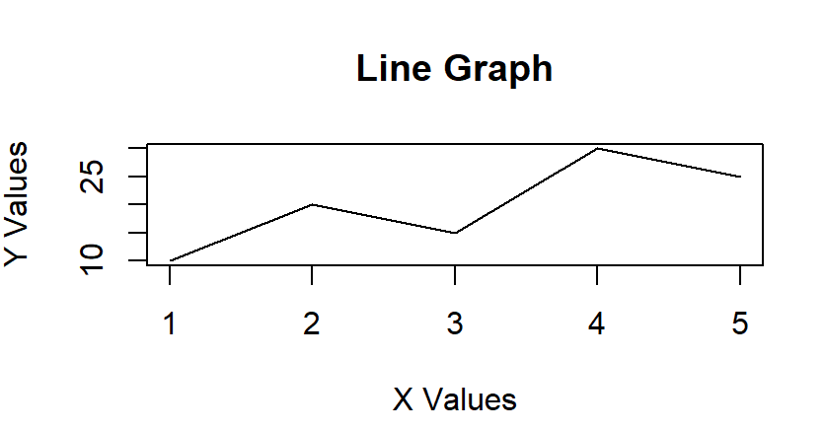

2. Bar Graph
Course <- c("BSc IT", "BSc CS", "BCA")
Students <- c(40, 35, 30)

barplot(Students,
names.arg = Course,
main = "Students by Course",
xlab = "Course",
ylab = "Students")

Output:
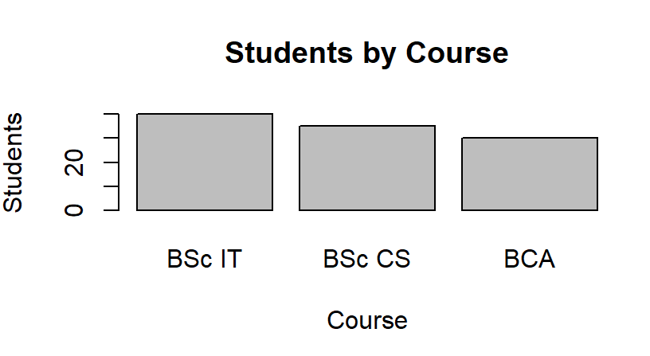

3. Pie Chart
Students <- c(40, 35, 30)
Course <- c("BSc IT", "BSc CS", "BCA")

pie(Students,
labels = Course,
main = "Students by Course")

Output:
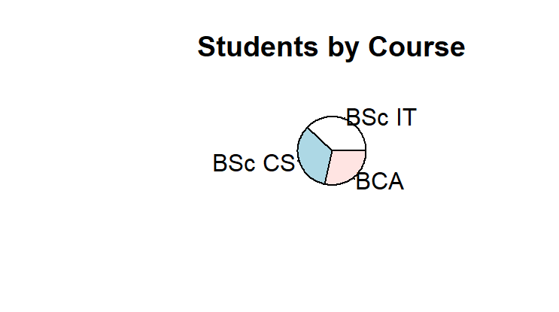
4. Histogram
Marks <- c(45, 50, 52, 55, 58, 60,
65, 68, 70, 72, 75, 80, 85, 90)

hist(Marks,
main = "Histogram of Marks",
xlab = "Marks",
ylab = "Frequency")

Output:
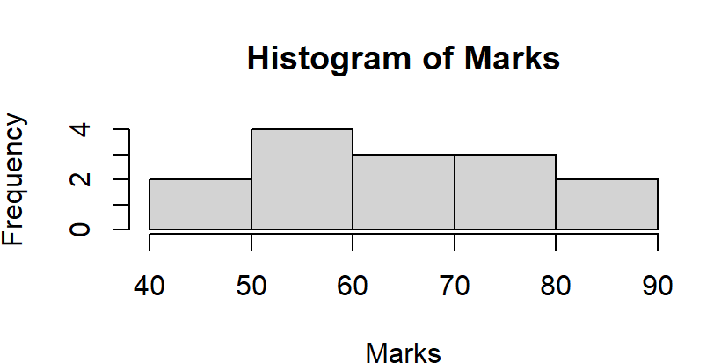

5. Box Plot
Marks <- c(45, 50, 55, 60, 65, 70, 72, 75, 80, 85, 90)

boxplot(Marks,
main = "Box Plot of Marks",
ylab = "Marks")
Output:

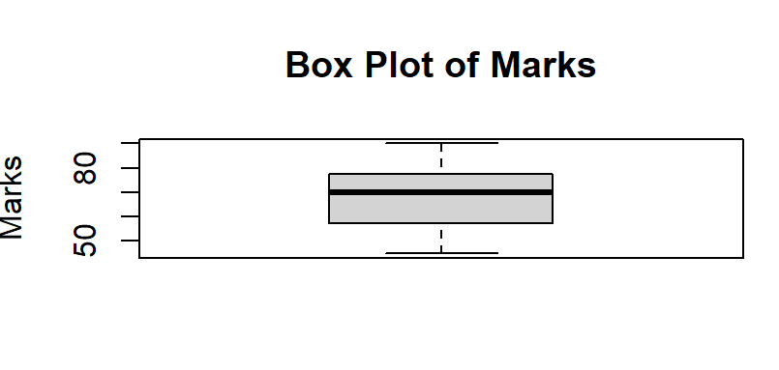

6. Scatter Plot
StudyHours <- c(1, 2, 3, 4, 5, 6, 7, 8)
Marks <- c(40, 45, 50, 58, 65, 70, 78, 85)

plot(StudyHours, Marks,
main = "Study Hours vs Marks",
xlab = "Study Hours",
ylab = "Marks",
pch = 19)

Output:
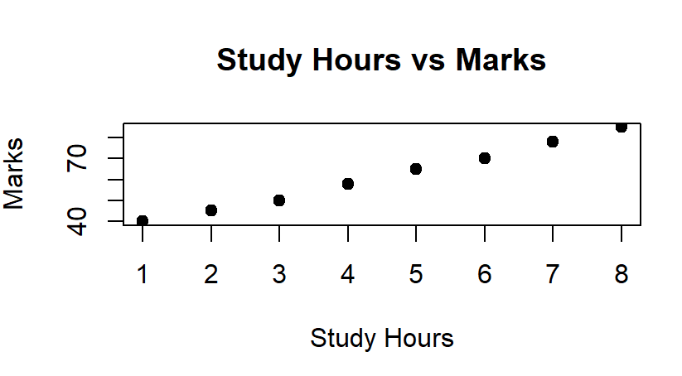

7. Frequency Polygon
Marks <- c(45, 50, 52, 55, 58, 60,
65, 68, 70, 72, 75, 80, 85, 90)

h <- hist(Marks, plot = FALSE)

plot(h$mids, h$counts,
type = "o",
main = "Frequency Polygon",
xlab = "Marks",
ylab = "Frequency")
Output:
